Name: Muhammad Uzair

Roll No. L1F18BSCS0311

Section - H

Database

Graded Lab 9

Task 1

create database WeddingDress;

use WeddingDress;

Task 2

create table customer (

CustomerID int(11),

CName varchar(10) NOT NULL ,

CAge int(3) NOT NULL,

CAddrs varchar(20) NOT NULL,

CContactNumber varchar(25),

primary key(CustomerID));

Task 3

insert into customer values (1, 'Ayesha', 24, 'Johar Town', '0300-1234567');

insert into customer values (4, 'Ahmad', 29, 'Wapda Town', '0333-1234567');

insert into customer values (6, 'Rameen', 27, 'DHA', NULL);

insert into customer values (2, 'Amina', 20, 'Model Town', '0321-1234567');

insert into customer values (3, 'Kashif', 18, 'Gulberg', '0313-1234567');

select * from customer;

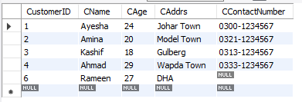

Task 4

create table Designer (

DesignerID int(11),

DName varchar(15) NOT NULL ,

DCategory varchar(20) NOT NULL,

DContactNumber varchar(25),

PRIMARY KEY(DesignerID));

Task 5

insert into Designer values (100, 'MariaB', 'Unstitched Ladies', '0300-7654321');

insert into Designer values (101, 'Charcoal', 'Men Dressing', '0333-7654321');

insert into Designer values (102, 'Sana Safinaz', 'Unstitched Ladies', '0321-7654321');

insert into Designer values (103, 'Khaadi', 'Unstitched Ladies', '0345-7654321');

insert into Designer values (104, 'Oxford', 'Warm Cloths', '0310-7654321');

select * from Designer;

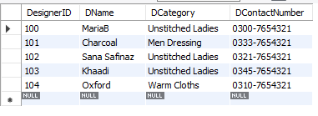

Task 6

create table CustomerDesigner (

CDID int(11) primary key,

CustomerID int(11) NOT NULL ,

DesignerID int(11) NOT NULL,

DressType varchar(20) NOT NULL,

Priority varchar(25) Default "Normal",

Foreign key(CustomerID) references customer(CustomerID),

Foreign key(DesignerID) references Designer(DesignerID));

Task 7

insert into CustomerDesigner values (1, 1, 103, 'Sari', 'Normal');

insert into CustomerDesigner values (2, 1, 102, 'Fancy Suit', 'Normal');

insert into CustomerDesigner values (3, 1, 103, 'Fancy Suit', 'Urgent');

insert into CustomerDesigner values (4, 4, 101, 'Waistcoat', 'Urgent');

insert into CustomerDesigner values (5, 4, 104, 'Sweater', 'Urgent');

insert into CustomerDesigner values (6, 6, 100, 'Fancy Suit', 'Normal');

insert into CustomerDesigner values (7, 2, 100, 'Winter Suit', 'Normal');

insert into CustomerDesigner values (8, 6, 100, 'Winter Suit', 'Urgent');

insert into CustomerDesigner values (9, 3, 104, 'Kurta', 'Normal');

insert into CustomerDesigner values (10, 3, 104, 'Sweater', 'Normal');

select * from CustomerDesigner;

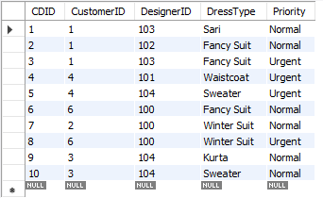

Task 8

select count(CDID) as customer_orders from CustomerDesigner;



Task 9

select CustomerID, count(CustomerID) as customer_orders from CustomerDesigner group by CustomerID;

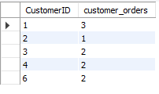

Task 10

select DesignerID, count(DesignerID) as Orders_Taken from CustomerDesigner group by DesignerID;

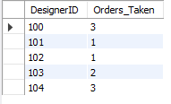

Task 11

select count(Priority) as Orders from CustomerDesigner where Priority = "Normal";



Task 12

select Cname, count(CustomerID) as orders

from customer

inner join CustomerDesigner

using(CustomerID)

group by(CustomerDesigner.CustomerID)

having orders > 1;

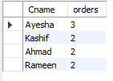

Task 13

select dname, count(designerid) as orders

from Designer

inner join customerdesigner

using(designerid)

group by customerdesigner.designerid

having orders = (select count(designerid) as taken

from Designer

inner join customerdesigner

using(designerid)

group by customerdesigner.designerid

order by taken desc limit 1);

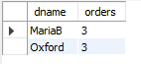

Task 14

select cname, count(customerid) as ordersGiven

from customer

inner join CustomerDesigner

using(CustomerID)

group by (CustomerDesigner.CustomerID)

having ordersGiven = (select count(customerid) as ordersGiven

from customer

inner join CustomerDesigner

using(CustomerID)

group by (CustomerDesigner.CustomerID)

order by ordersGiven asc limit 1);



Task 15

select Dname

from Designer

order by Dname asc limit 1;



Task 16

select Customer.Cname , Designer.Dname

from Customer

inner join CustomerDesigner

using(CustomerID)

inner join Designer

using(DesignerID) limit 1;



Task 17

select customer.cname, CustomerDesigner.dresstype

from Customer

inner join CustomerDesigner

using (Customerid);

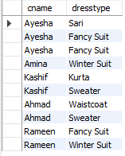

Task 18

select Customer.Cname, Designer.Dname, CustomerDesigner.Priority

from Customer

inner join CustomerDesigner

using(CustomerID)

inner join Designer

using(DesignerID);

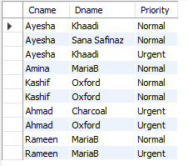

Task 19

alter table designer MODIFY DCategory varchar(35);

describe designer;

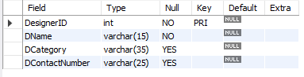

Task 20

UPDATE designer

set DCategory = 'Unstitched Ladies Suit'

where Dcategory = 'Unstitched Ladies';

select * from designer;

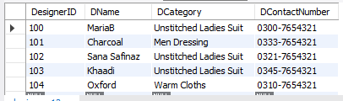

Task 21

select Customer.Cname, CustomerDesigner.DressType, CustomerDesigner.Priority

from Customer

inner join CustomerDesigner

using(CustomerID)

inner join Designer

on Designer.DesignerID = CustomerDesigner.DesignerID and Designer.Dname = 'MariaB';

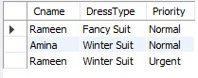

Task 22

delete from customerdesigner where customerid = 3;

delete from customer where cname = 'Kashif';

select * from customer;

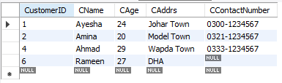

select * from customerDesigner;

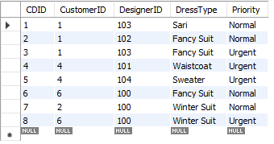

Task 23

Update Designer

set DContactNumber = '0300-1111111'

where Dname = 'Khaadi';

select * from designer;

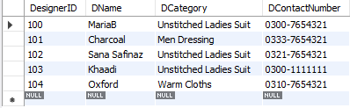

Task 24

select Dname, DContactNumber

from designer

inner join CustomerDesigner

on Designer.DesignerID = CustomerDesigner.DesignerID and CustomerDesigner.Priority = 'Urgent';

